**Batch: A – 3 (H3 – 2)**

**Roll no.: 16014022050**

**Experiment: 07**

|  |
| --- |
| **Title: To create an effective Dashboard.** |

# Objective:

# *Search/locate and download any Data of Your Choice (Use same dataset if it contains location information)*

# *To learn how to create Dashboard*

# *Apply best practices to create Dashboard.*

# Course Outcome:

# CO1: Learn how to locate and download datasets, extract insights from that data and present their findings in a variety of different formats

# CO3: Apply data visualization best practices

# CO4: Design static charts, interactive Dashboards and data stories

# Books/ Journals/Websites referred:

<https://www.tableau.com/learn/articles/data-visualization>

<https://www.tableau.com/learn/articles/data-visualization-tips>

# Resources used:

<https://www.youtube.com/watch?v=6oFTdbrugUs&ab_channel=AndyKriebel>

https://www.youtube.com/watch?v=oAIubTqg-Kw&ab_channel=DataTutorials

# Theory:

# Describe content related to dashboard:

I have created a comprehensive dashboard that delves into various aspects of global weather patterns and their relationships across different regions and time frames.

My dashboard focuses on general weather patterns and atmospheric conditions in different countries during specific months and days. It emphasizes the correlation between humidity and rainfall through a dual-axis line graph. Additionally, the area line graph illustrates the percentage of cloudiness, while the map graph showcases the distribution of UV index across different regions. The depiction of moon phases with varying colors and sizes based on illumination provides an aesthetic representation of celestial events tied to weather.

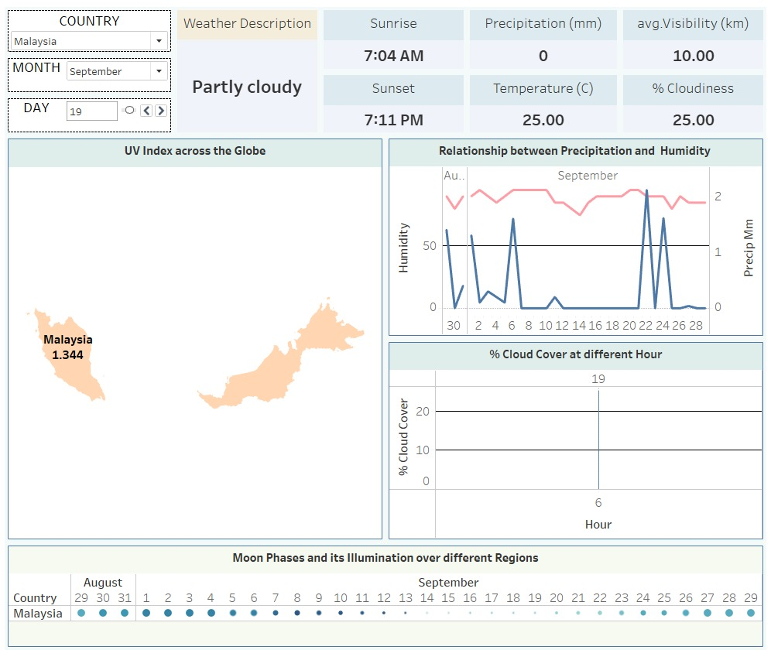

The dashboard's focus on general weather patterns and atmospheric conditions, along with the correlation between humidity and rainfall, is necessary as it provides a comprehensive understanding of how these factors interact and influence the overall climate. By including the percentage of cloudiness and the distribution of the UV index, the dashboard offers a holistic view of the various elements that contribute to the overall weather conditions. The depiction of moon phases adds a nuanced layer, connecting celestial events to weather phenomena and demonstrating their potential impact on environmental conditions.

Through this analysis, we can derive several important results. Firstly, understanding the correlation between humidity and rainfall can provide insights into the likelihood of precipitation in specific regions during particular times of the year. Additionally, the depiction of cloudiness percentage can help predict visibility and potential weather disruptions. The distribution of the UV index across different regions can highlight areas that are more prone to intense sunlight and the associated risks, enabling the implementation of appropriate precautions. Furthermore, the incorporation of moon phases can help identify any potential impact on tides, atmospheric pressure, and potentially even human behavior, providing a more holistic understanding of the complex interactions between celestial events and weather patterns.

# Following points should be written by students:

# Best practices of effective Dashboard.

# Create Dashboard.

# Create Accessible Dashboard.

# Create Dashboard Layouts for Different Device Types.

# Publish the dashboard online.

# Conclusion (Students should write in their own words, comparative conclusion needed):

# Through this Tableau data visualization experiment, I have gained practical knowledge in creating interactive dashboards, effectively implementing various data visualization techniques. Applying the best practices has enhanced my understanding of creating visually appealing and user-friendly dashboards that effectively communicate complex information.

**Date: _____________ Signature of faculty in-charge**

# Post Lab Question:

# Explain the Advantages and Disadvantages of Dashboard.

# Advantages:

# Data Visualization: Dashboards provide a visually appealing and intuitive way to represent complex data, making it easier for users to comprehend large datasets and identify trends and patterns quickly.

# Real-Time Monitoring: They enable real-time monitoring of key performance indicators, allowing businesses to make informed decisions promptly based on the most up-to-date information.

# Centralized Information: Dashboards consolidate data from various sources into a single, easily accessible platform, providing a comprehensive overview of an organization's performance and metrics.

# Enhanced Decision-Making: By providing clear and concise insights, dashboards facilitate informed decision-making, helping businesses identify strengths, weaknesses, and opportunities, thus fostering strategic planning and goal alignment.

# Disadvantages:

# Complex Data Integration: Integrating data from various sources into a unified dashboard can be challenging, requiring extensive data cleaning, standardization, and compatibility checks.

# Data Overload: Poorly designed dashboards with excessive data or complex visualizations can overwhelm users, leading to confusion and difficulty in extracting meaningful insights.

# Cost and Maintenance: Developing and maintaining a robust dashboard infrastructure can be resource-intensive, requiring skilled personnel, software licenses, and ongoing technical support.

# Security Concerns: Dashboards may contain sensitive and confidential data, raising security concerns. Ensuring data privacy and implementing robust security measures is essential to protect against unauthorized access and data breaches.

# Understanding these advantages and disadvantages is crucial for leveraging dashboards effectively and mitigating potential drawbacks to maximize their utility in facilitating data-driven decision-making and enhancing organizational performance.